PRESS RELEASE

FOR IMMEDIATE RELEASE

For more information on the topic:
Contact: Steffen Coonan & Ciaran O’Brien
E-mail: erraproject@gmail.com
Date: 09/April/2016

ERRA PROJECT RELEASE DEBUT E.P.

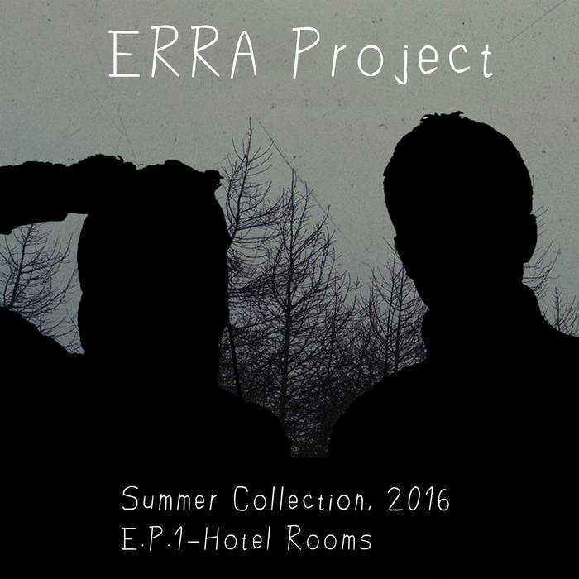
Munster based producers form electronic duo ‘ERRA Project’ and release 80’s inspired debut E.P. entitled “Hotel Rooms”.
The ERRA Project was formed in early 2016 by Cork based sound technician and musician Ciaran O’Brien, and Tipperary based music producer and DJ Steffen Coonan, with the vision to enrich people’s lives through collaborative music projects. Armed with traditional and electronic instruments, the duo have been hard at work in Steffen’s home studio crafting an 80’s inspired E.P. with a modern punch. The 4 track E.P., entitled “Hotel Rooms”, is released April 14th 2016.

The ERRA Project formed upon the member’s realisation that they shared the same musical taste and production goals. Using the equipment and knowledge the two have picked up in their professional careers, the debut E.P. was self engineered, mixed, and mastered. The ERRA Project enlisted vocal support on the debut E.P. from Grace Tooher (former “Staring at Lakes” vocalist) and Morgan d’Arcy (“Quangodelica” vocalist).

Ciaran O’Brien has worked freelance as an audio technician and guitar player for almost 10 years. Steffen Coonan is the founder of the successful media solutions service “Hillyfield Productions” and popular Deep House website www.DJSteffenCoonan.com. Find the ERRA Project’s music and contact them at:

https://erraproject.bandcamp.com/releases
https://www.youtube.com/watch?v=OMkvSOsAmmU
https://twitter.com/ErraProject
https://www.facebook.com/erraproject
####

